**GIT Manual**

# Account Info

* Github user 1: chema3520
* Github user 2: Ch3M@x/Ch3M4x
* Github user 2 password: Hackboy + Universal #

# How To’s

## Share Github repository with user

* Add the new user as a contributor in Github

## Stash

Allows to clean the repository by taking the modified tracked files and staged changes into a stack of unfinished changes which can be reapplied at any time.

There can be multiple stash in the stack.

### Push to the Stash stack

1. Right click the root folder of the repository and select **TortoiseGIT -> Stash Save** option.

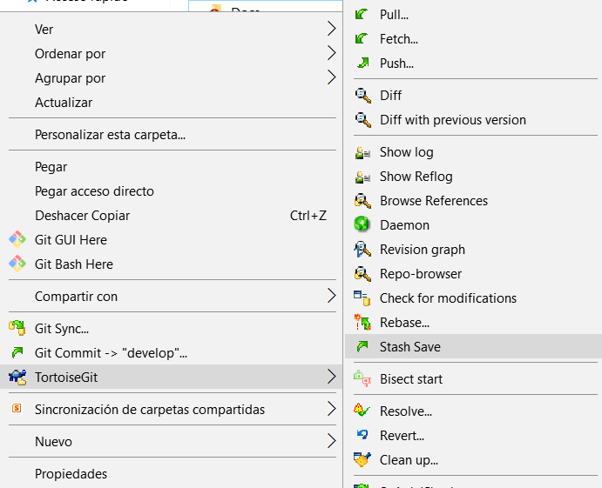

1. Set a message for the stash. Check the **--all** option to also include unstaged files.

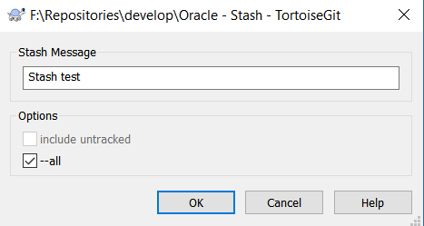

1. Notice the folder is now clean.

### Pop from the Stash stack

1. Right click the root folder of the repository and select **TortoiseGIT -> Stash Pop** option.

Alternatively use the **Stash List** option to view the stash stack.

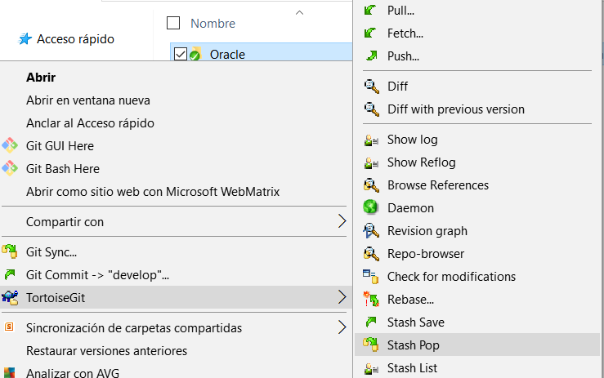

1. Wait for the operation to complete.
2. Check that the changes are reapplied.

## Commit

Allows to commit/save changes into the local repository.

1. Right click the root folder and select **Git Commit -> <branch_name>** option.
2. Specify a message for the commit and check any files that are going to be included in the commit.

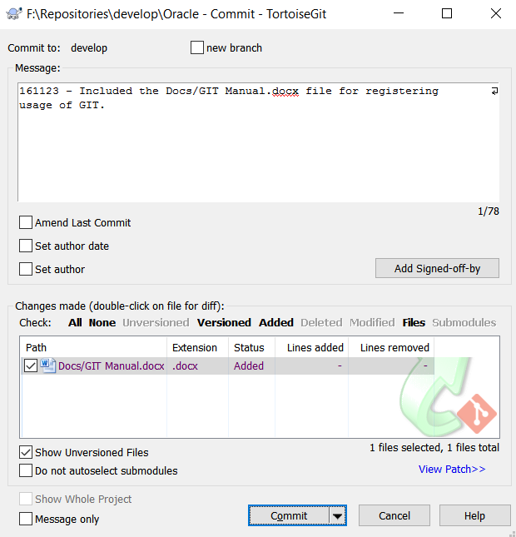

1. Click the **Commit** button.

## Push

Uploads the commited changes to the remote repository.

1. Right click the root folder and select the **TortoiseGit -> Push** option.

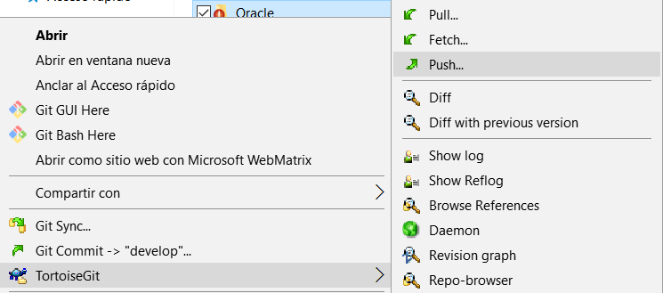

1. Use default settings and click **OK** button.

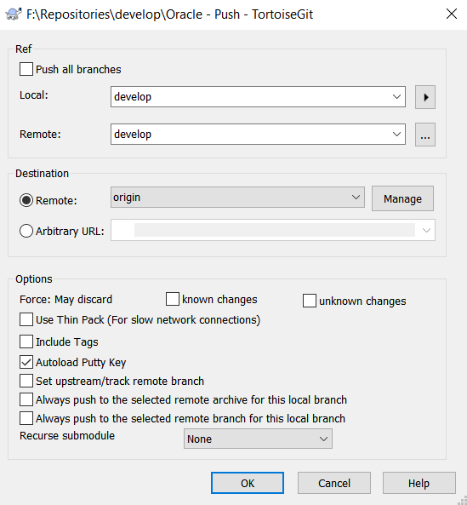

1. Wait for the operation to complete.
2. Validate that the changes were applied to the remote repository.